**6. Install Arduino IDE and Driver**

1. **Installing Arduino IDE**

When we get control board, we need to download Arduino IDE and driver firstly.

You could download Arduino IDE from the official website:

<https://www.arduino.cc/>, click the **SOFTWARE** on the browse bar, click“DOWNLOADS” to enter download page, as shown below:

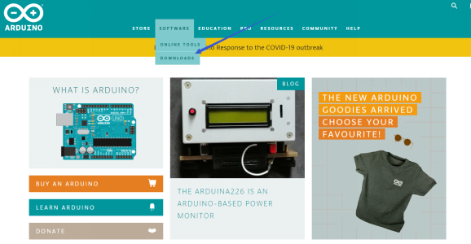

There are various versions Of IDE for Arduino, just download a version that compatible with your system, here we will show you how to download and install the windows version Arduino IDE.

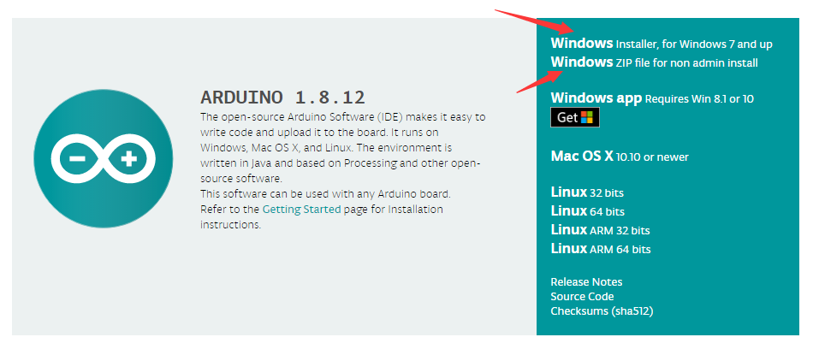

There are two versions of IDE for WINDOWS system, you can choose between the installer (.exe) and the Zip packages. For installer, it can be directly downloaded, without the need of installing manually. For Zip package, you need to install the drivers manually.

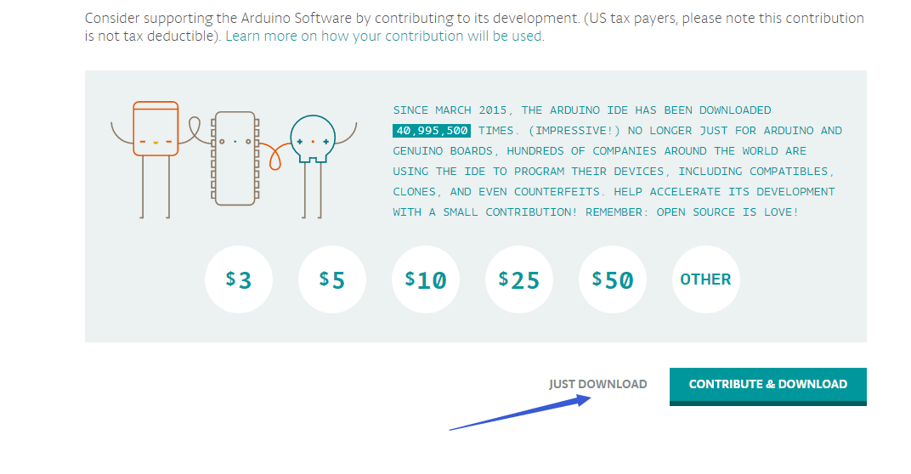

You just need to click JUST DOWNLOAD.